Trouble shooting
Problem | Cause | Solution
Blades fail to clip | Lack of oil / Obstructed blades | Unplug clipper and clean the blades. Clear any obstructions. Oil blades every 5-10 minutes
Blades fail to clip | Blades fitted incorrectly | Unplug clipper. Correctly re-fit the blades
Blades fail to clip | Blunt or damaged blades | Unplug clipper and replace the blades. Send blunt blades for re-sharpening
Blades get hot | Lack of oil | Oil every 5-10 minutes
Blades get hot | “Cutting air” | Keep blades on the animal between strokes
Power cuts out | Power source is being  overloaded | Unplug clipper. Clean, oil, and correctly tension the blades. Replace or reset the fuse where applicable
Power cuts out | Loose connection | Unplug clipper and power source. Inspect cables and  connectors for damage. Use a qualified repairer
Power cuts out | Lack of oil | Oil every 5-10 minutes
Excessive noise | Blades fitted incorrectly / Driving socket damaged | Unplug clipper and remove the blades. Check for damage. Replace if necessary. Re-fit correctly
Excessive noise | Possible malfunction | Have clipper checked by a qualified repairer
Other

Warranty & disposal

• Items requiring attention under warranty should be returned to your dealer
• Repairs must be carried out by a qualified repairer
• Do not dispose of this product in household waste

caution: Never handle your Clipper while you are operating a water faucet, and never hold your clipper under a water faucet or in water. There is danger of electrical shock and damage to your clipper.

Introduction
Thank you for purchasing our professional clippers

The clipper gives you the freedom to clip how and where you please from a choice of power sources. it performs like a mains powered clipper. It is used for dog, cat etc small animal with 10# blade, and horse, cattle etc big animal with 10W blade.

• Clipping horses and ponies for competition, for leisure, for housing, and for health
• Clipping cattle for shows, for market, and for cleaning
• Clipping of dogs, cats and other pets

Technical date
Working voltage: 100-240V AC
Motor voltage : 7.4V DC
Working current: 1.5A
Weight: 330g
Working speed: 4200/3600/3000RPM
Detachable blade: 10# or OEM.
Certificate : CE UL FCC ROHS

SAFETY INTORMATION
When using an electrical appliance, basic precautions should always be followed, including the following: Read all instructions before using the Clipper.
DANGER: To reduce the risk of electric shock:
1. Do not reach for an appliance that has fallen into water. Unplug immediately.
2. Do not use while bathing or in a shower.
3. Do not place or store appliance where it can fall or be pulled into a tub or sink. Do not place in or drop into water or other liquid.
4. Always unplug this appliance from the electrical outlet immediately after using.
5. Unplug this appliance before cleaning, removing, or assembling parts.
WARNING: To reduce the risk of burns, fire, electric shock, or injury to persons:
1. An appliance should never be left unattended when plugged in.
2. Close supervision is necessary when this appliance is used by, on or near children or individuals with certain disabilities.
3. Use this appliance only for its intended use as described in this manual. Do not use attachments not recommended by instruction.
4. Never operate this appliance if it has a damaged cord or plug, if it is not working properly, if it has been dropped or damaged, or dropped into water. Return the appliance to an repair shop or repair.
5. Keep the cord away from heated surfaces.
6. Never drop or insert any object into any opening.
7. Do not use outdoors or operate where aerosol (spray) products are being used or where oxygen is being administered.
8. Do not use this appliance with a damaged or broken blade or comb, as injury to the skin may occur.
9. To disconnect turn control to “off” then remove plug from outlet.
10. WARNING: During use, do not place or leave appliance where it may be (1) damaged by an animal or (2) exposed to the weather.
OPERATING INSTRUCTIONS
Please read the following instructions before using your new Clipper. Give it the care that a fine precision built instrument deserves and it will give you years of service. Plug cord into electrical outlet, operate 110-230 volt, 50-60 cycle AC electrical current or as noted on unit.
3-SPEED OPERATION
Your Detachable Plus comes with normal and high speed operation. Use the normal setting for most cutting needs. Use the high speed setting for cutting through heavy hair. After using your Clipper, rewrap cord, and store in a safe place.
REMOVING BLADE SET
To remove blade set, first make sure your clipper motor is switched “OFF”.
A. Push locking button (1) in and hold.
B. Push blade assembly(2) upward to position(3)
C. Blade assembly can now be removed from clipper by pulling forward and upwards at (4)

NOTE: When pushing the blade assembly back into the clipper it must be inserted with the smooth side of the blade facing upwards, damage to the clipper or injury may result. Then turned “ON”, push the blade towards the clipper to lock into position.

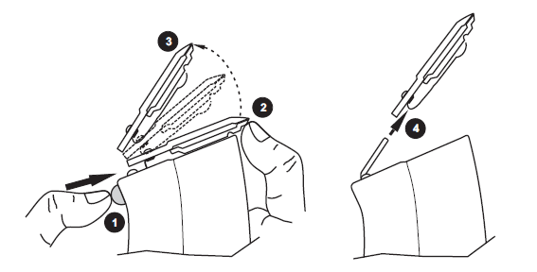
USER MAINTENANCE
The internal mechanism of your motor clipper has been permanently lubricated by the factory. Other than the recommended maintenance described in this manual, no other maintenance should be performed.
CARE AND SERVICING OF YOUR CLIPPER BLADES
Blades should be oiled before, during, and after each use. If your clipper blades leave streaks or slow down, it’s a sure sign blades need oil. Place a few drops of oil on the front and side of the cutter blades (Diagram 1). Wipe excess oil off blades with a soft, dry cloth. Spray lubricants contain insufficient oil for good lubrication, but are an excellent clipper blade coolant. Always replace broken or nicked blades to prevent injury. You can clean the excess hair from your blades by using a small brush or worn out toothbrush. To clean the blades, we suggest to immerse the blades only into a shallow pan of Clipper Oil, while the clipper is running. Any excess hair and dirt that has accumulated between the blades should come out. After cleaning, turn your clipper off and dry blades with a clean dry cloth and start clipping again. If upon cleaning your blades you find that the blades will still not cut, there may be a few fine pieces of hair trapped between the upper and lower blade. If this happens, you will need to snap the blade off the clipper. Proceed to slide the upper blade to one side, without loosening the tension spring or moving the upper blade completely out from under the tension spring (See Diagram 2 for position of blade). Wipe the surface between the blades clean with a dry cloth, then place a drop of clipper oil where the upper and lower blades meet and also in the guide slot of the tension spring (Diagram 2). Now slide the upper blade to the opposite side of the lower blade and repeat this process. After completing this procedure, slide the upper blade, centering it over the lower blade. Handle or store your Clipper with the blades down so excess oil will not run into the clipper case.
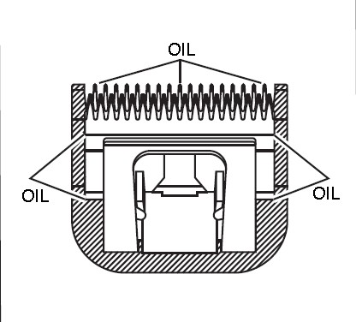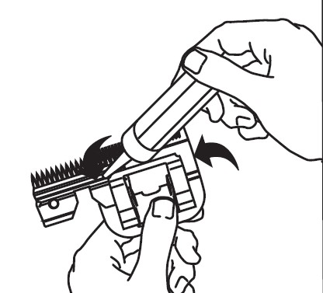
Diagram 1 Diagram 2

